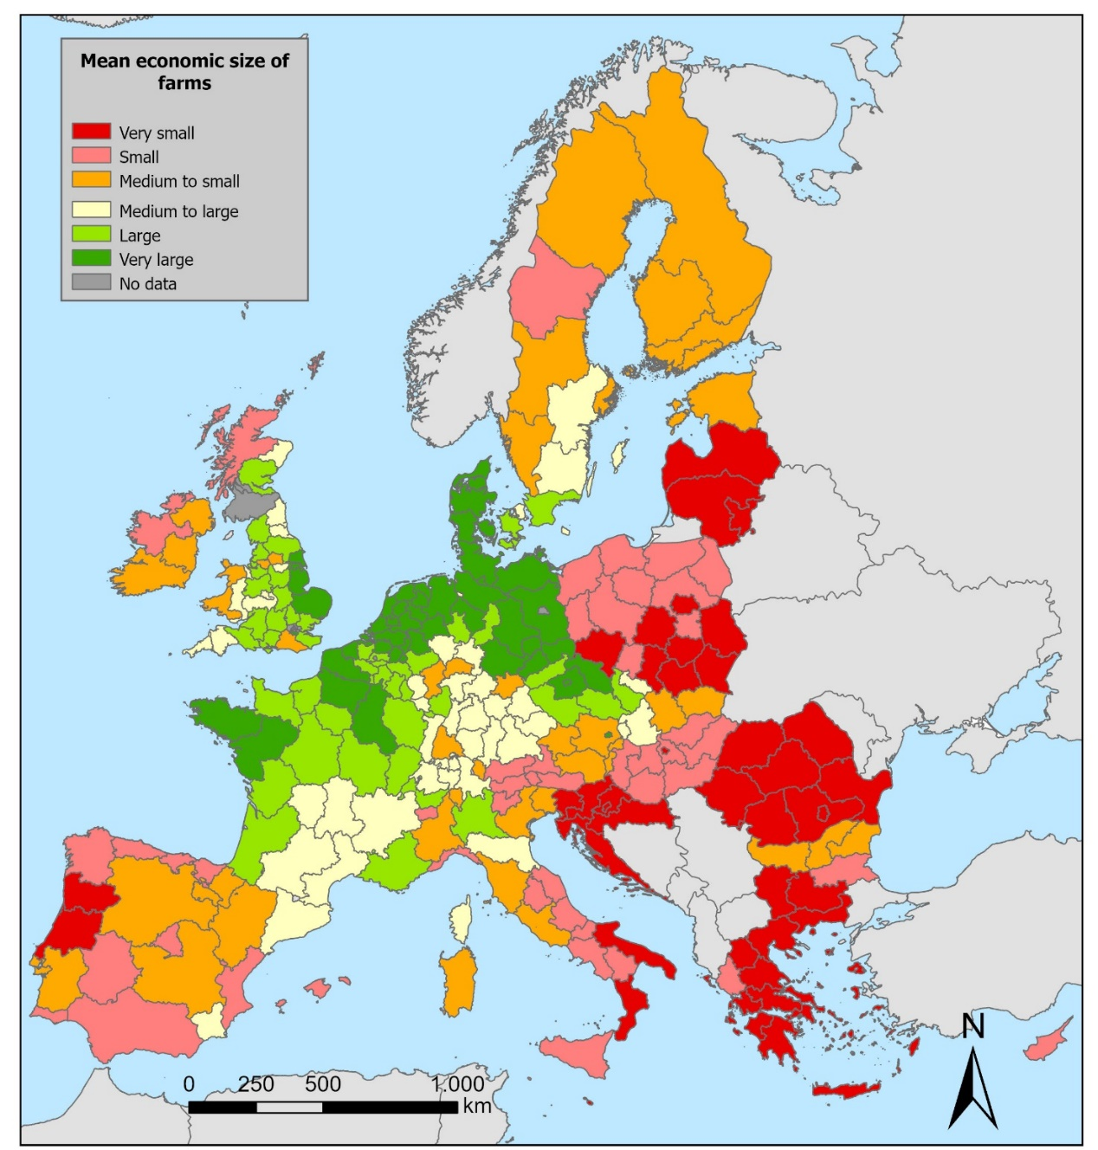

Figure 13. Mean economic size of farms of the NUTS 2 regions in the EU27, UK and CH. Data obtained from Eurostat (2016, 2020).

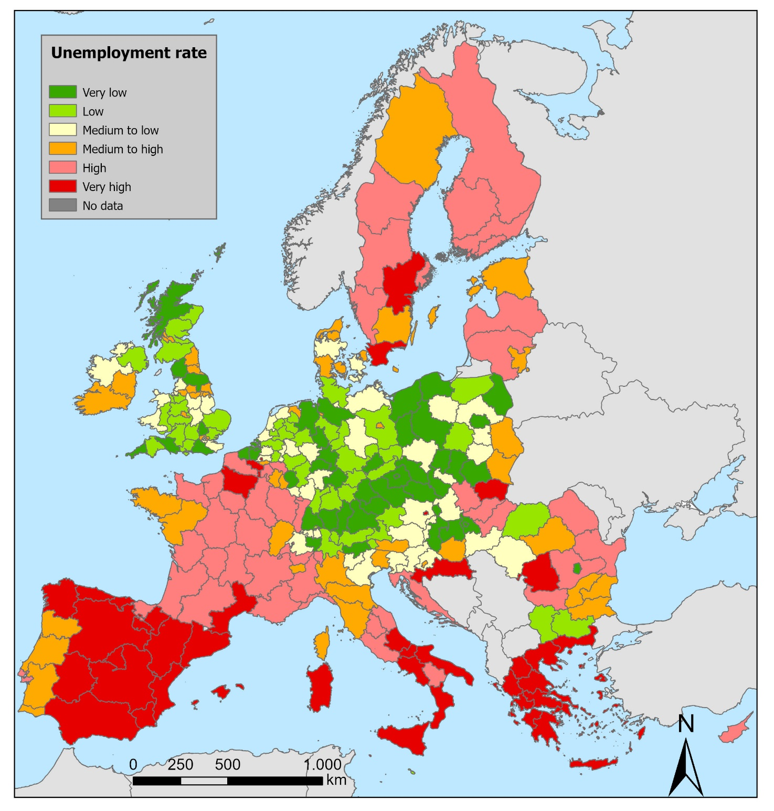

Figure 14. Unemployment rates of the NUTS 2 regions in the EU27, UK and CH. Source: Eurostat (2016, 2020).

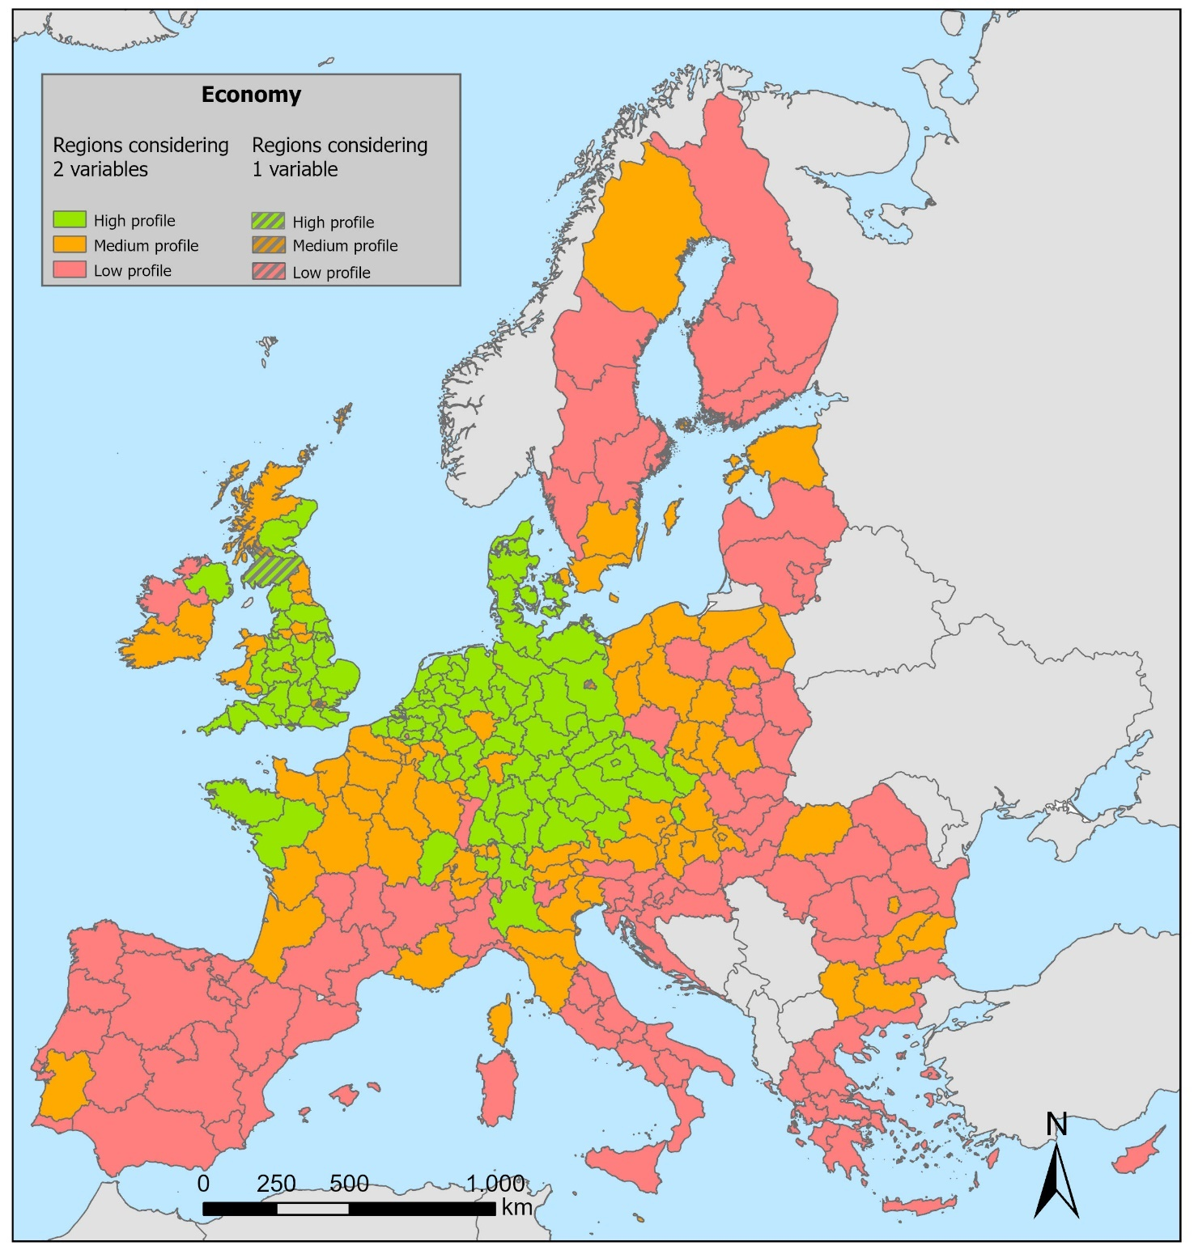

Figure 15. Combination of the economic variables (unemployment rate and mean economic size of farms) to characterize NUTS 2 regions in different profiles.

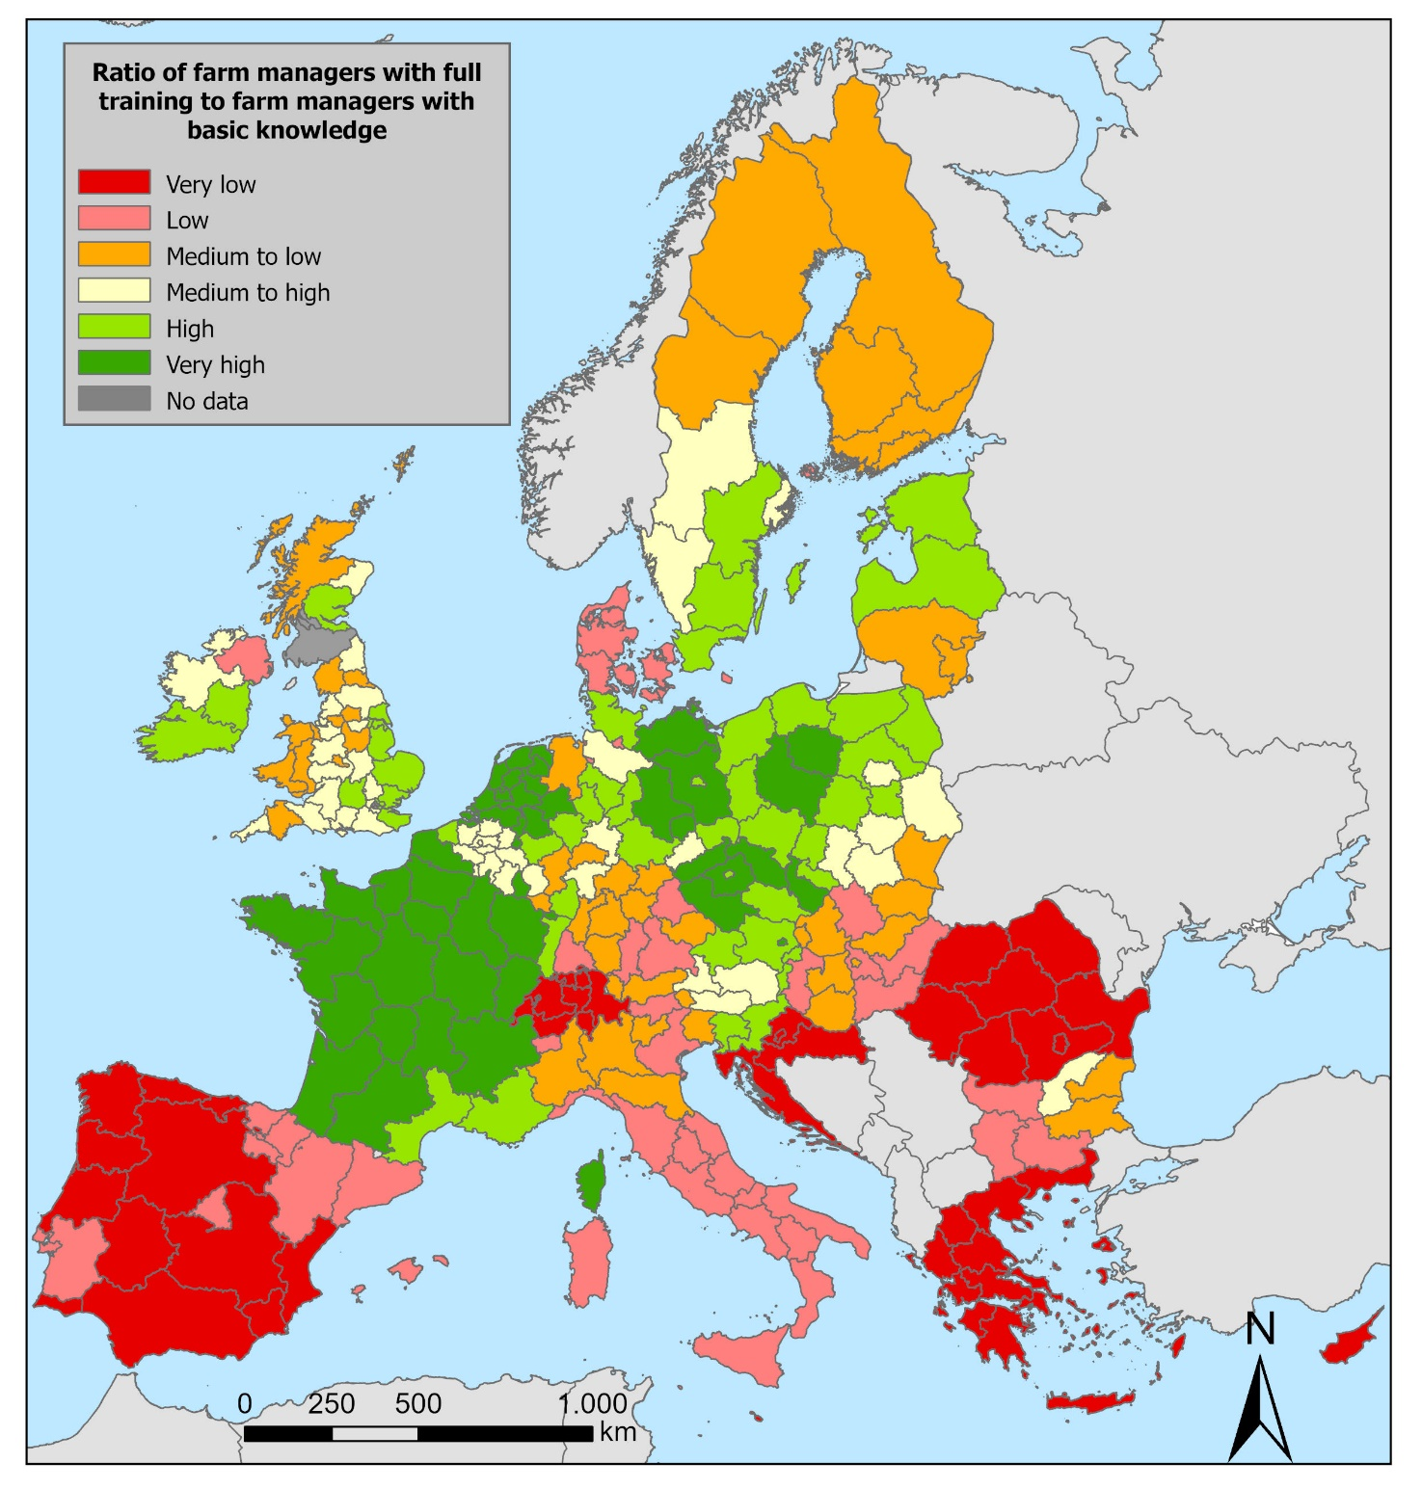

Figure 16. Ratio of farm managers with full training to farm managers with basic knowledge and practical experience only in the NUTS 2 regions in the EU27, UK and CH. Source: Eurostat (2023) (2016, 2020).

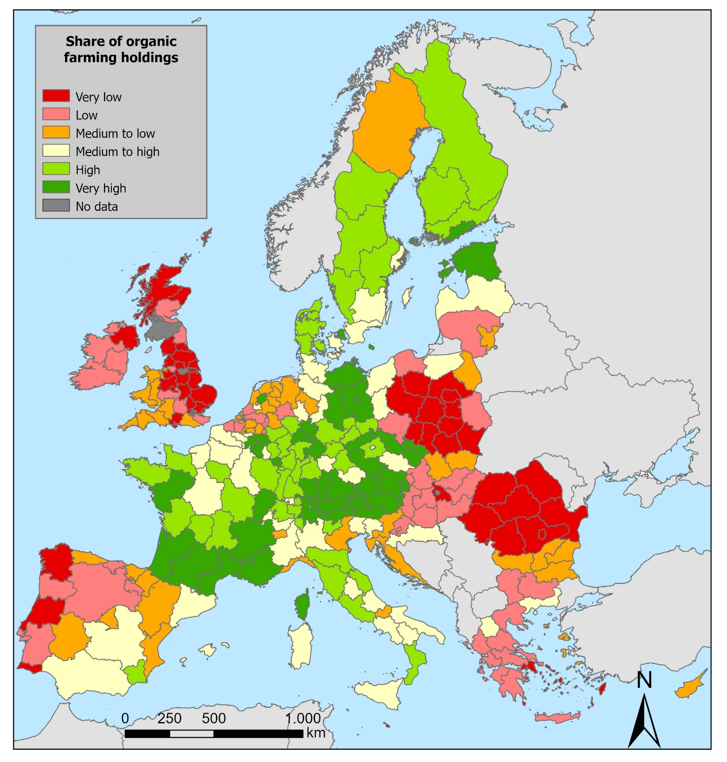

Figure 17. Share of organic farming holdings in the NUTS 2 regions in the EU27, UK and CH. Source: Eurostat (2020) (2016).

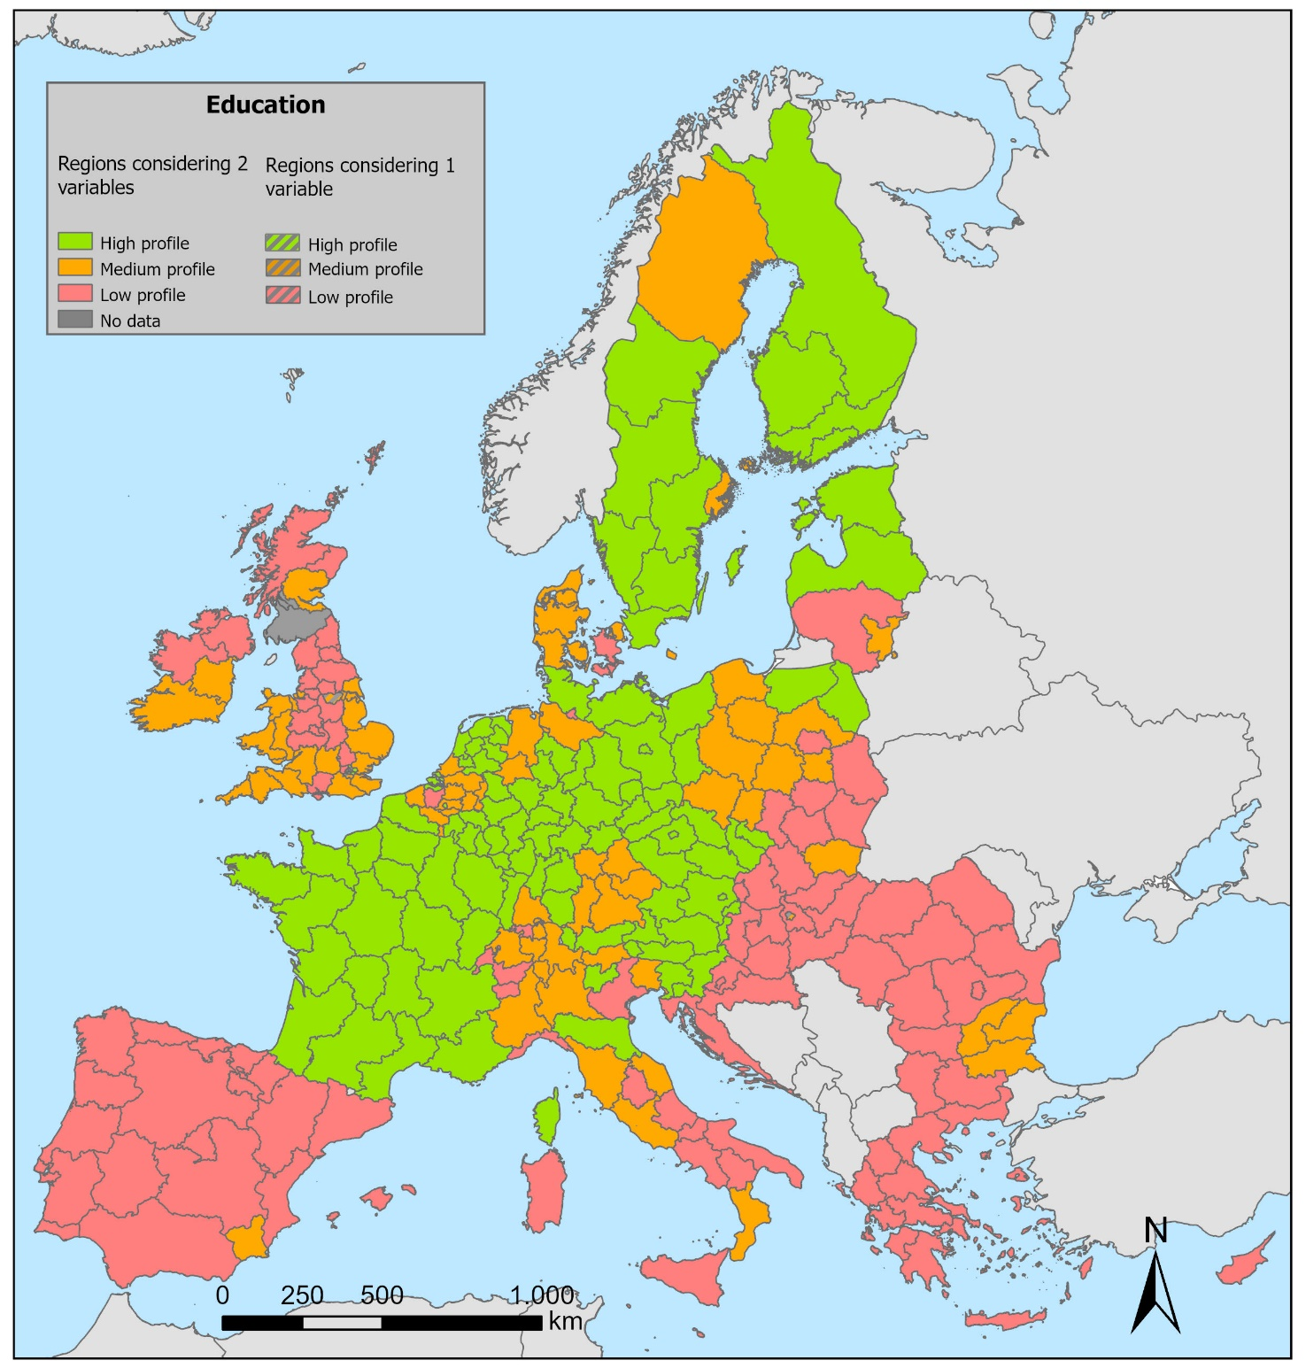

Figure 18. Combination of education-related variables (share of organic farming holdings and ratio of farm managers with full training to farm managers with basic knowledge and practical experience only) to characterize NUTS 2 regions in different profiles.

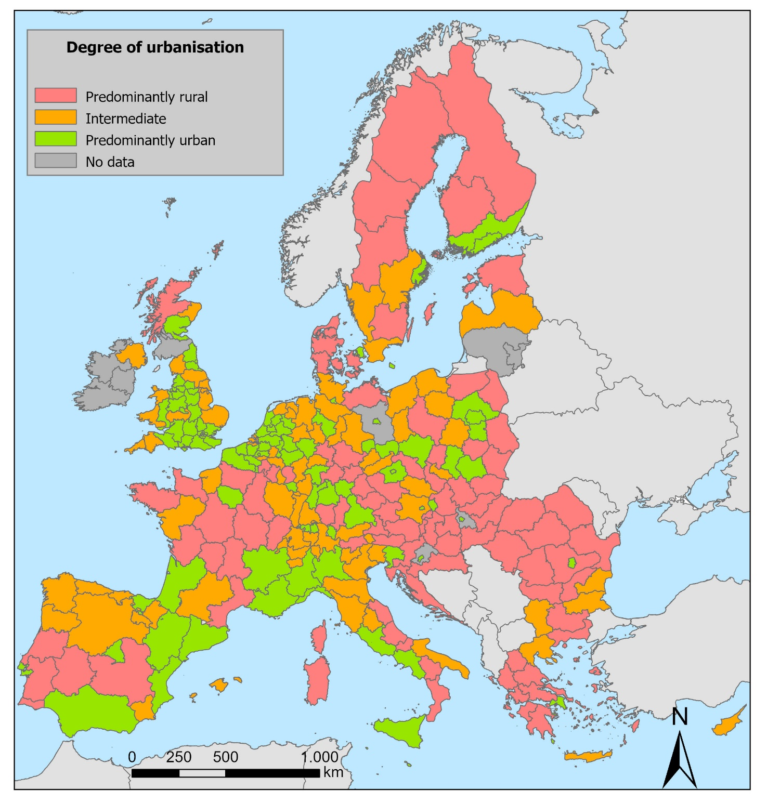

Figure 19. Degree of urbanisation at NUTS 2 level for the year. Values were subdivided into three classes. Source: de Beer et al. (2014).

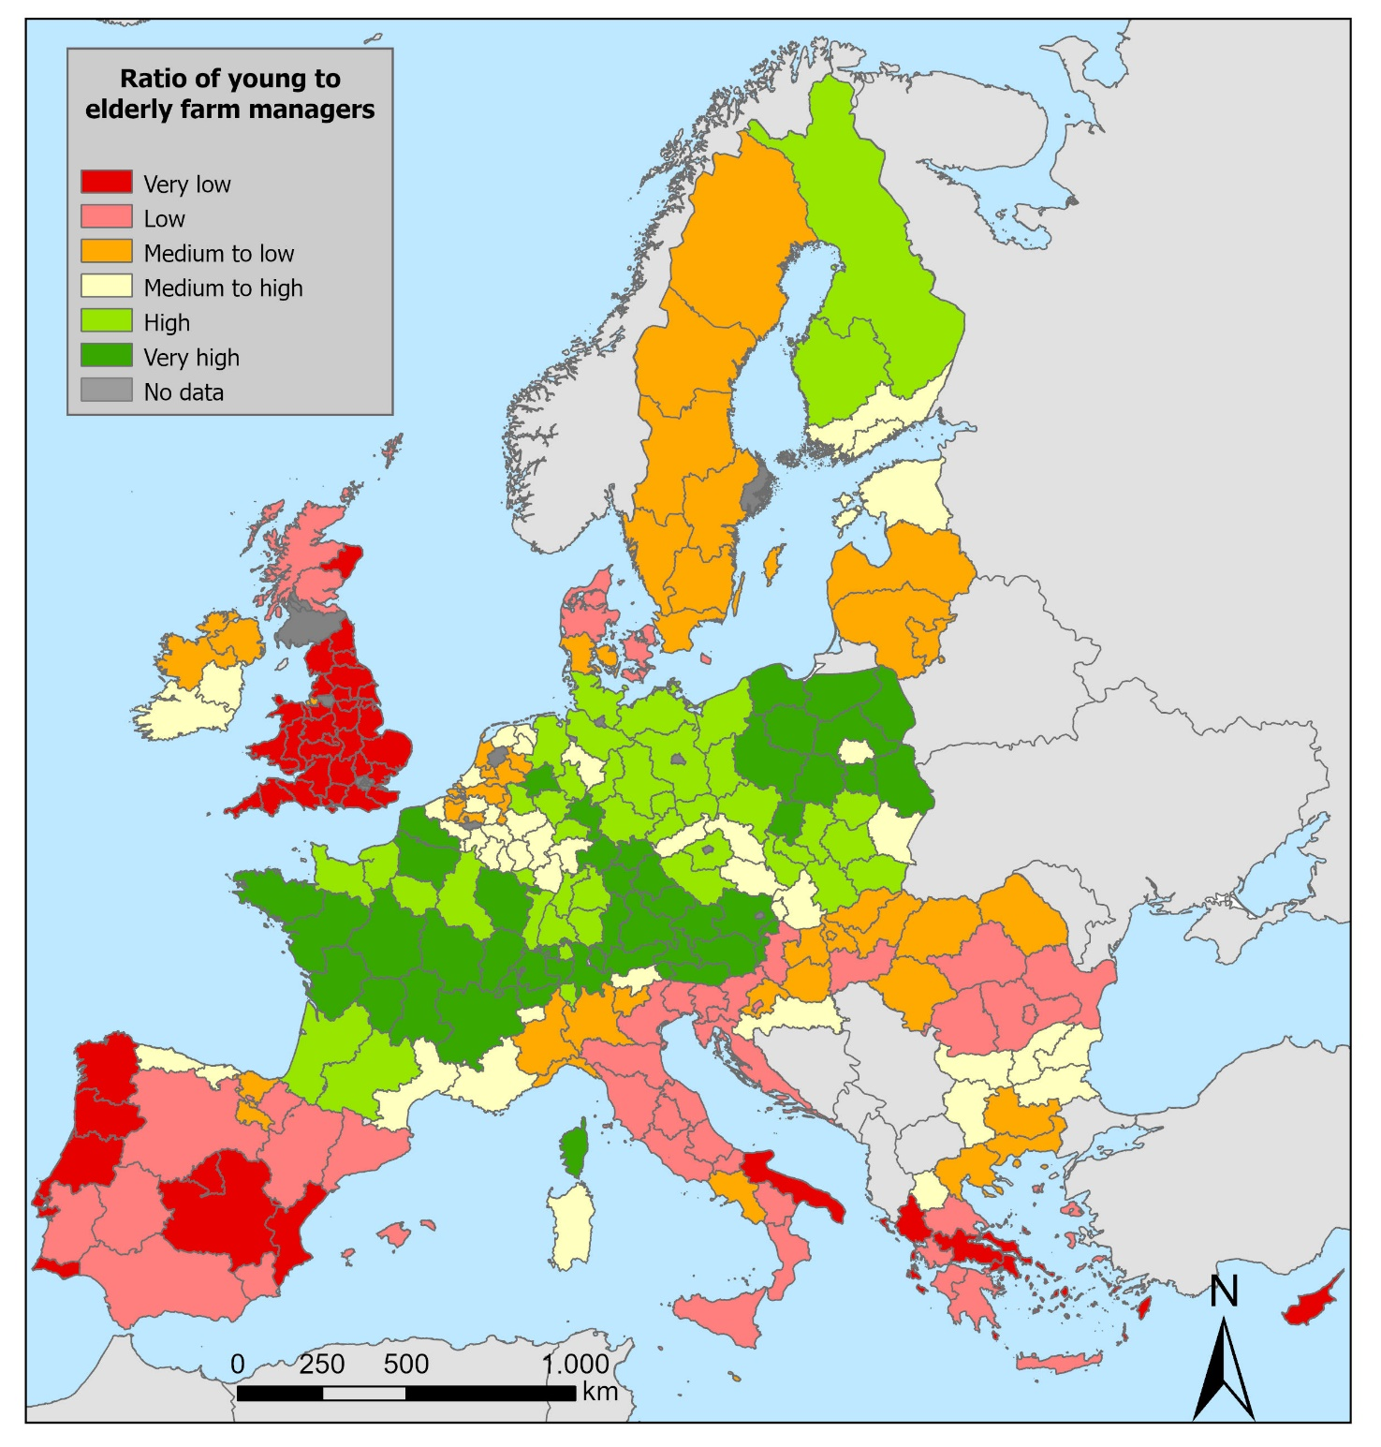

Figure 20. Ratio of young farm managers to elderly farm managers in the NUTS 2 regions in the EU27, UK and CH. Source: Eurostat (2016, 2020).

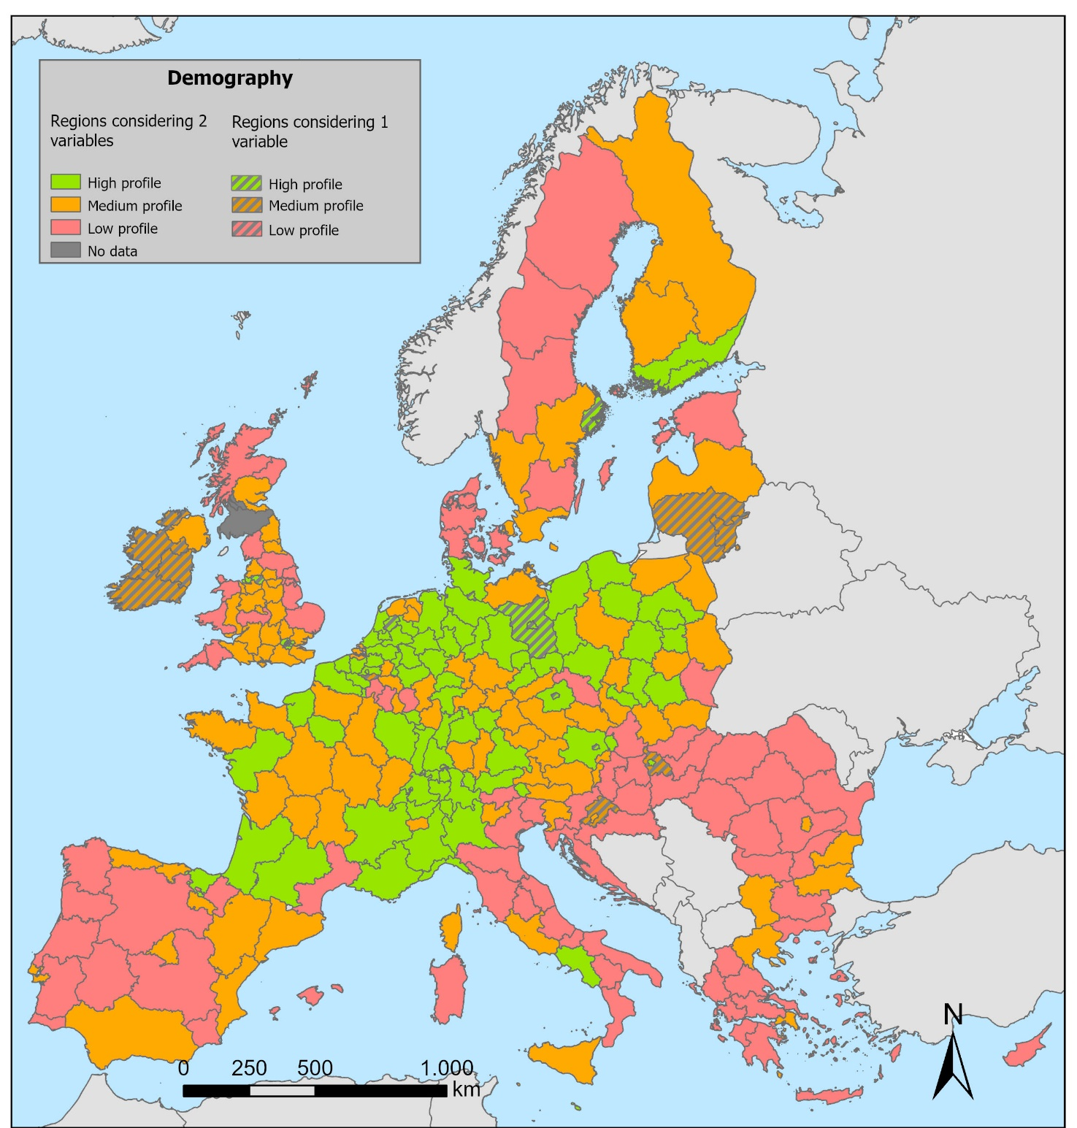

Figure 21. Combination of demography-related variables (degree of urbanisation and ratio of young farm managers to elderly farm managers) to characterize NUTS 2 regions in different profiles.

## ***Annex 5. Map of accumulated biodiversity-related pressures (0-5 environmental pressures) in the potential agricultural area to introduce agroforestry and mixed farming: pest control index, pollinator potential, potential threats to soil biological functions, potential threats to soil fauna and potential threats to soil microorganisms.***

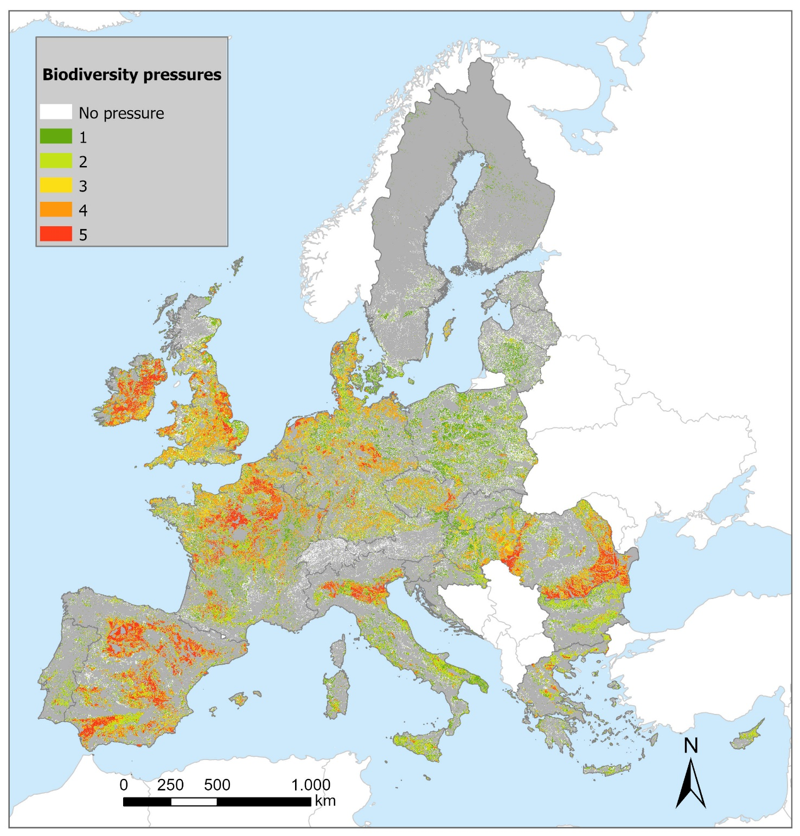

Table 23. Description of the socio-economic contexts, including classes and profiles.

|  |  |  |  |
| --- | --- | --- | --- |
| **Context (C)** | **Sum of classes** | **Socio-economic factors** | **Profile** |
| **C1** | **Very high** and **high** share/ratio: organic farming holdings **+** farmers with full training **+** young farmers **+**  **Very large** and **large** economic size **+**  **Very low** and **low** unemployment rates **+**  **Urban** | More organic farming,  More educated farmers,  Younger farmers,  Larger farms,  Lower unemployment rates,  Predominantly urban regions. | High profile |
| **C2** | Regions not included in C1 or C3. | This is an intermediate context. | Intermediate profile |
| **C3** | **Very low** and **low** share/ratio: organic farming holdings **+** farmers with full training **+** young farmers **+**  **Small** and **very small** size farms **+**  **Very high** and **high** unemployment rates **+**  **Rural** | Less organic farming,  Less educated farmers,  Older farmers,  Smaller farms,  Higher unemployment rates,  Predominantly rural regions. | Low profile |

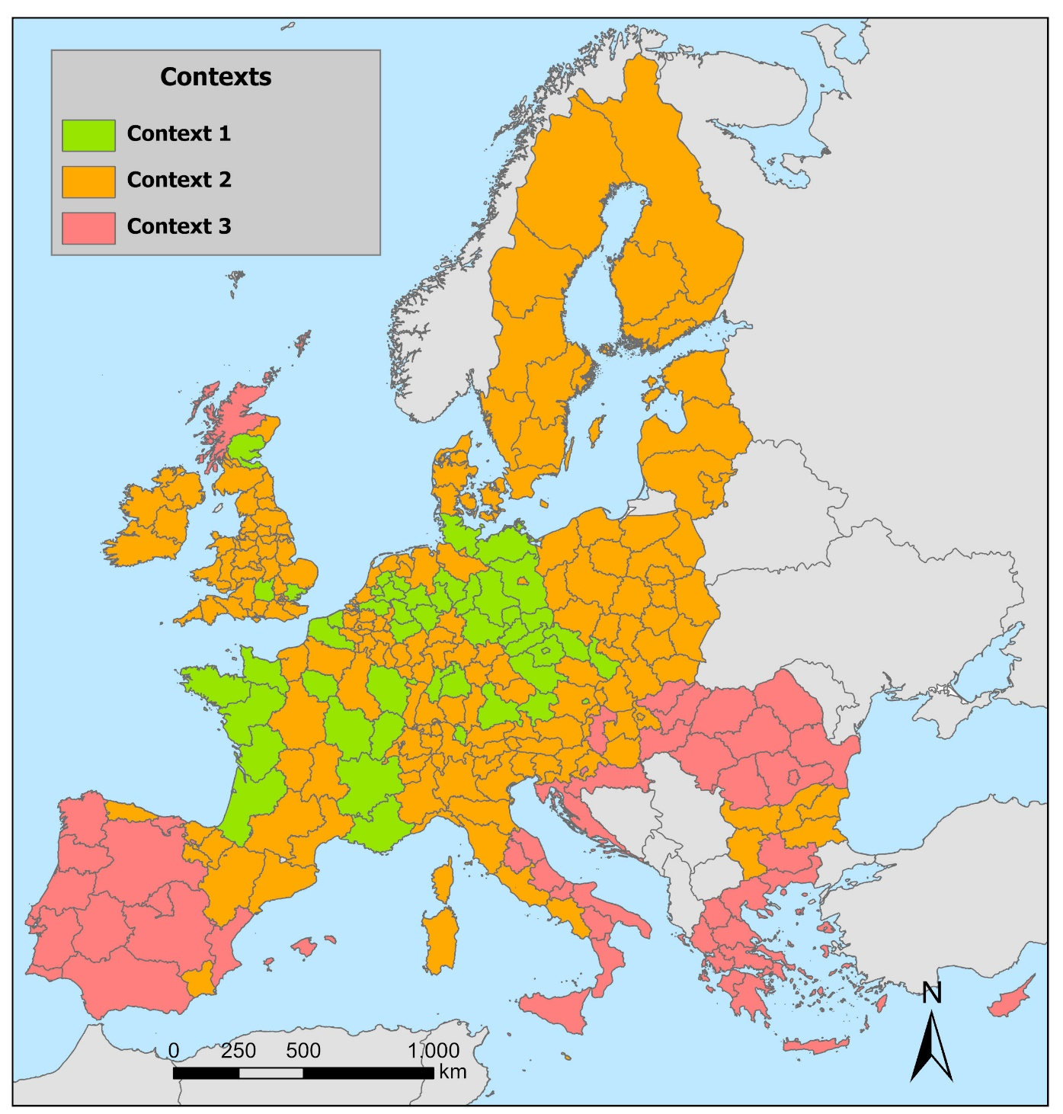

Figure 22. Socio-economic contexts 1, 2 and 3 in the EU27, UK and CH.

## ***Annex 6. Map of accumulated climate change pressures (0-4 environmental pressures) in the potential agricultural area to introduce agroforestry and mixed farming: annual mean temperature change, aridity index, drought frequency and heavy precipitation days.***

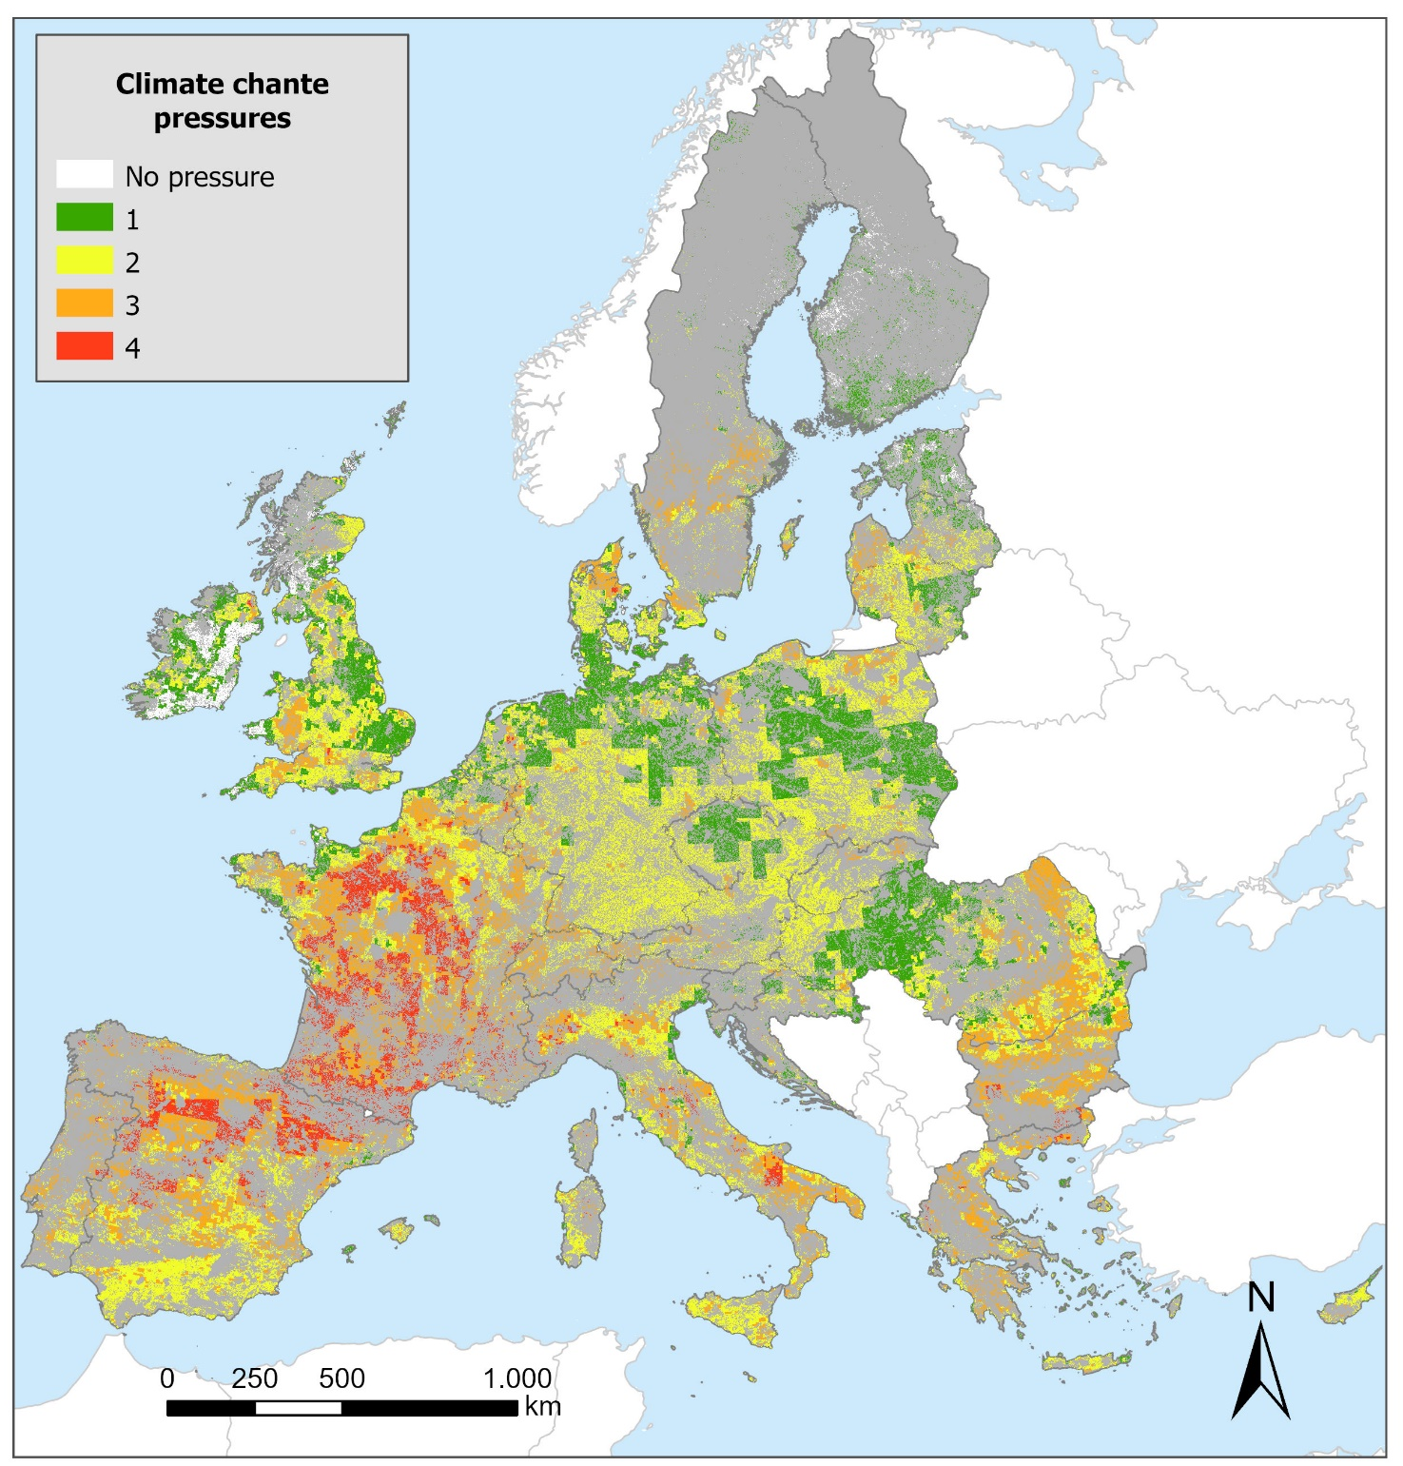

## ***Annex 7. Map of accumulated soil pressures (0-3 environmental pressures) in the potential agricultural area to introduce agroforestry and mixed farming: water erosion, wind erosion, and soil organic carbon (SOC) saturation capacity.***

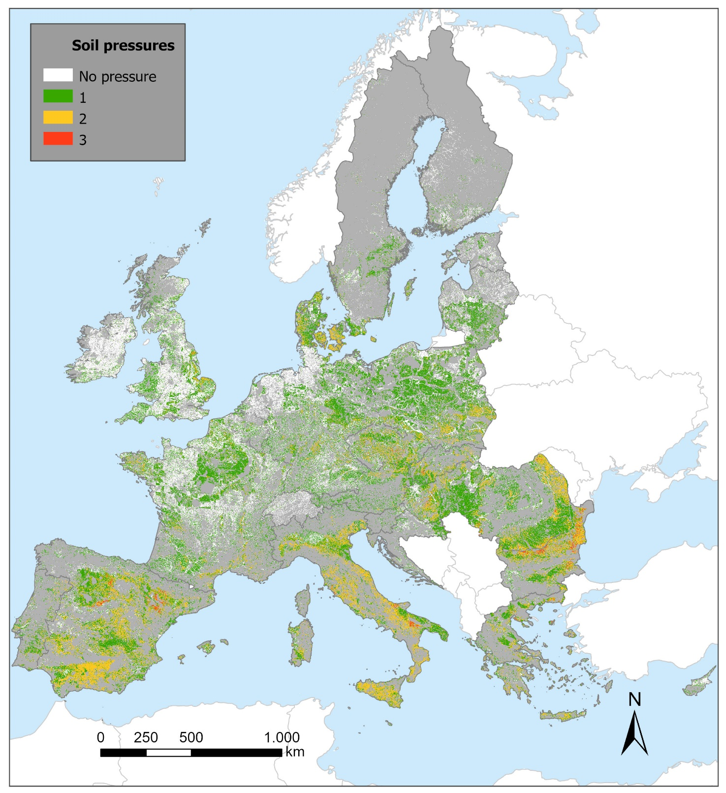

## ***Annex 8. Map of accumulated water pressures (0-2 environmental pressures) in the potential agricultural area to introduce agroforestry and mixed farming: nitrogen surplus and percentage of irrigated areas.***

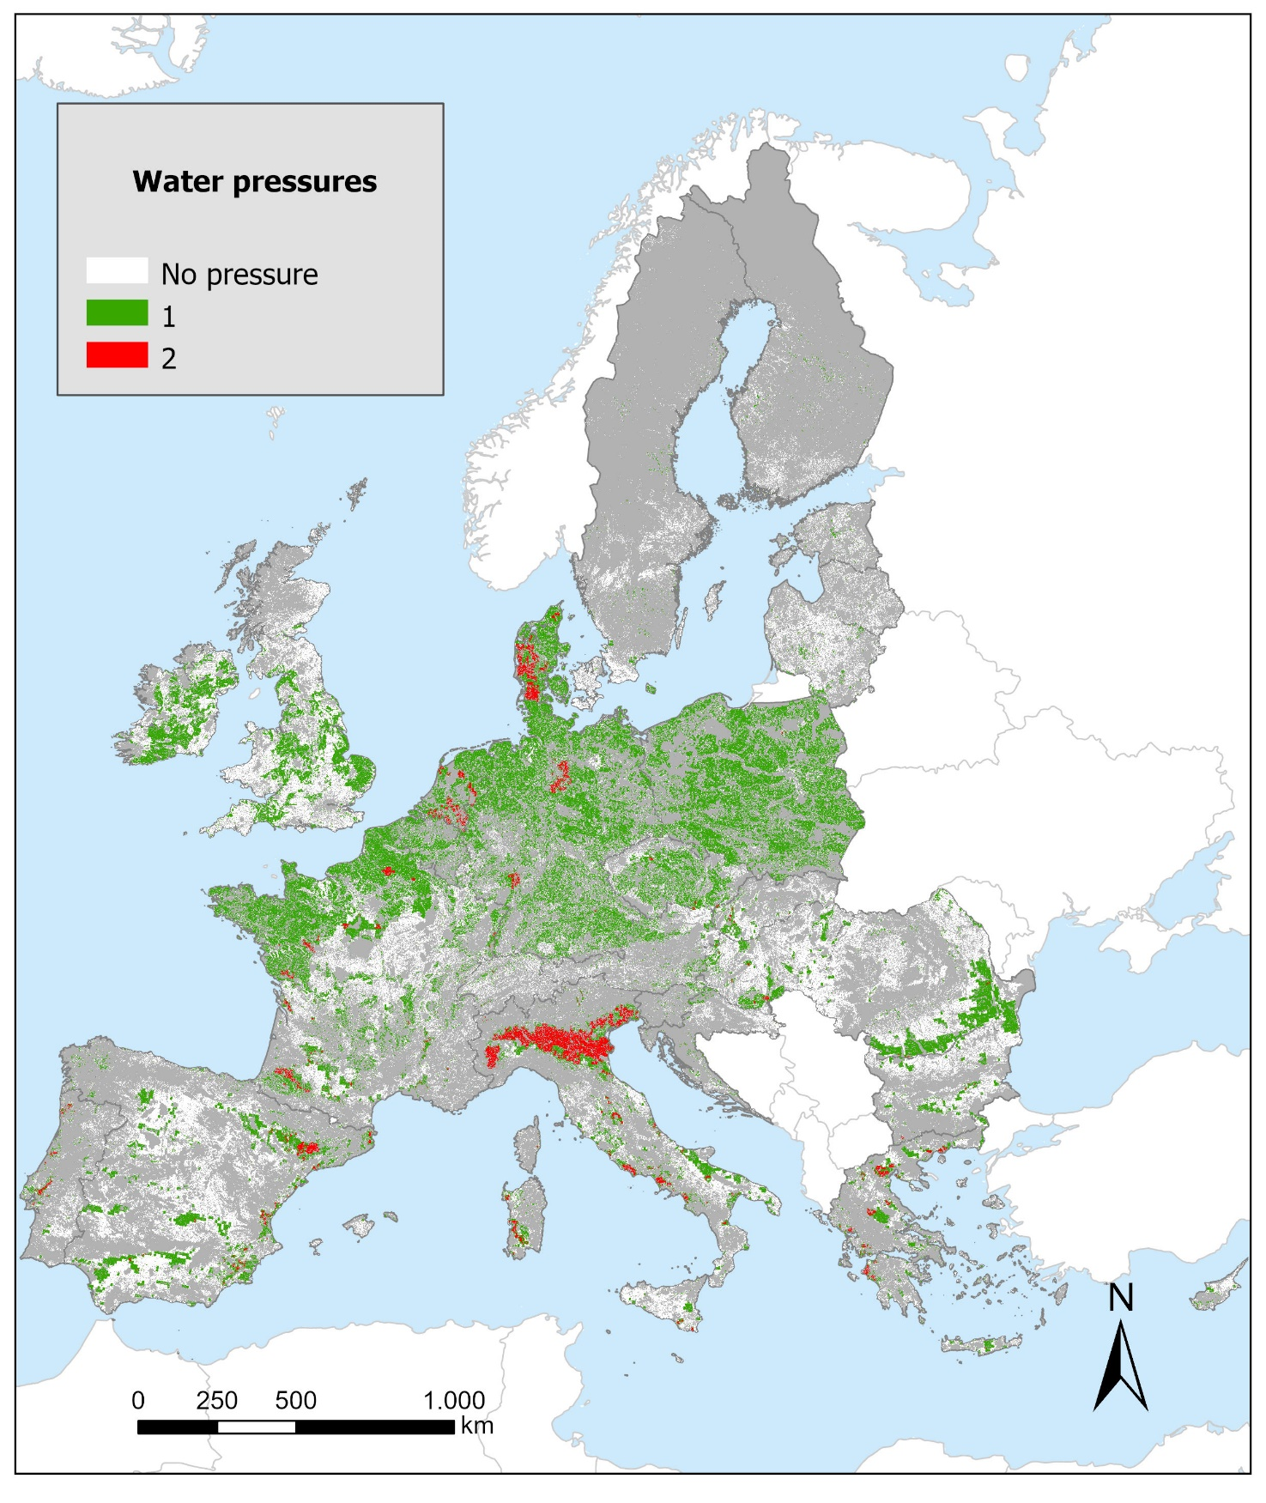

## ***Annex 9. Map of accumulated biodiversity, soil and water-related pressures (0-10 environmental pressures) in the potential agricultural area to introduce agroforestry and mixed farming.*** *Soils****: water erosion, wind erosion, and soil organic carbon (SOC) saturation capacity.*** *Biodiversity****: pest control index, pollinator potential, potential threats to soil biological functions, potential threats to soil fauna and potential threats to soil microorganisms.*** *Water****: nitrogen surplus and percentage of irrigated areas.***

